Present their Open 10 Mile Time Trial &
The Coaching Revolutions Shropshire Championship 10
Friction and Hydraulic Services Shropshire Championship Points Series – R2/8
Promoted for and on behalf of Cycling Time Trials under its rules & regulations
Saturday 8th August, 2020 – 2pm
Officials:-
Timekeeper: David Fletcher
Asst Timekeeper: Bernard Hutson-Lumb
Recorder: John Sherlock
Event Secretary: Steven Ford s.ford237@btinternet.com
Headquarters:- Ellerdine Village Hall Field Car Park, Hall Heath Lane, Ellerdine, Telford, Shropshire, TF6 6QT. http://www.evh.btck.co.uk/. There is a large playing field adjacent to the village hall for parking which will also have a gazebo where the HQ will be this year.
Please do not park near the start, particularly Sytch Lane as this has been the subject of resident complaints in the past.
Course D10/23R:- Waters Upton - Hodnet
Start at stop line from unclassified road signposted 'Ellerdine & Rowton' north of Waters Upton. Proceed north along A442 to Espley Island (Hodnet) 5.15 miles. Encircle island and retrace to Finish opposite gateway approx 25 yds south of northern exit of Sytch Lane. 10 miles.
At the Finish:- The Timekeeper has requested that you please shout out your race number as you pass the finish line at the end of your race. Also any rider making their way to the start line through the finish line that is not racing, please indicate you aren’t racing as you cross the line with a ‘side to side’ wave of your hand.
Covid Safety:-
- Please ensure you adhere to the latest Government guidelines including the latest social distancing requirements at all times.
- When parking, please leave at least a 2 metre gap between cars, preferably ‘top & tailed’ parking and keep windows closed whilst parked.
- Competitors should not attend if they feel ill in ANY WAY or if family members have any symptoms.
- An elevated resting heart rate or exceptionally quick to react heart rate during warm up can suggest an underlying asymptomatic illness of ANY kind. You should NOT start the event (DNS) and leave immediately. Do not go to the start line if you feel this is the case and notify the event organiser (Gary Wade) of your intension not to start as a result of an adverse warm up.
- No changing facilities will be available so please arrive ‘race ready’
- Preferably all warm-ups should be done on the road. However, if you do chose to do a static warm-up, ensure you adhere to social distancing at all times.
- Riders MUST NOT gather in anyway regardless of current guidelines in the car park, HQ area or elsewhere.
- Competitors on finishing MUST NOT stop at the finish and MUST NOT loiter at the HQ / car park but MUST pack away and leave immediately upon completion of the race.
- No support can be provided if a competitor suffers mechanical difficulties. It is strongly advised that all competitors carry with them a spare inner tube / tubular, pump and tyre levers if required
- It is also strongly advised that all competitors carry a mobile phone and take with them the telephone number of the event organiser, Gary Wade. Please telephone the organiser if you have failed to finish the event.
- Sign On / Sign Off:- Will be outside in the car parking field under a gazebo with sign on / off sheets taped to a table. Please BRING YOUR OWN PEN to sign on / off and sanatize your hands before sign on/off & number collection.
- Race Numbers:- Your disposable race numbers will be available for pick up at sign on. Please ensure you BRING YOUR OWN SAFETY PINS (if required) to attach your race numbers for the race and dispose of your race number after use.
- Toilet Facilities:- The toilet facilities in the village hall will be restricted to a ‘one in / one out’ basis so if alternative arrangements can be made, this would be recommended to avoid queuing where possible.
- Waiting at the Start:- To avoid queuing at the start, please only arrive at the start 3 minutes before your start time. There should be no more than 3 riders queuing at the start at any one time and always at least a bike length apart. If riders arrive early and these conditions cannot be met, they should continue warming up until closer to the start time.
- No Push Off at the start:- There will not be a ‘pusher offer’ at the start so all competitors must start with one foot on the ground (no track stand starts)
- CTT Regulation 17d - Signing Off:- Competitors MUST return to the event HQ either during the event or within a reasonable time after the last rider has finished and sign the official signing out sheet. Please ensure you sign off with your own pen and after you have sanatized your hands. NB Do not return your disposable race number.
General Riding Safety:-
Riders are advised to warm up off course in the lanes towards the start. Please ride with your head up at all times and respect the rules of the road as laid down in the Highway Code. Do not perform U-turns on the course within sight of the start and finish points (Failure to comply will lead to disqualification). IN THE INTERESTS OF YOUR OWN SAFETY Cycling Time Trials and the event promoters strongly advise you to wear a HARD SHELL HELMET that meets an internationally accepted safety standard. In accordance with Regulation 15 ALL JUNIOR competitors MUST wear protective hard shell helmets.
A WORKING REAR LIGHT, either flashing or constant, must be fitted to your machine in a position visible to following road users and be active whilst the machine is in use. No working rear light will result in a DNS
Poor Road Surface & pot holes:- It is recommended that you leave enough time before the race starts at 2pm to drive the course and observe the road surface. Please be aware there are areas of poor road surface and ‘repaired’ pot holes. Some examples are shown in the photos below:-

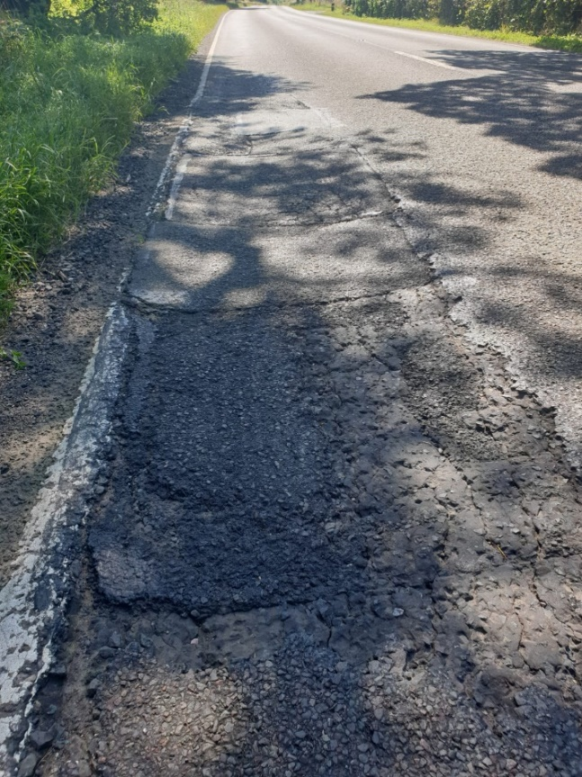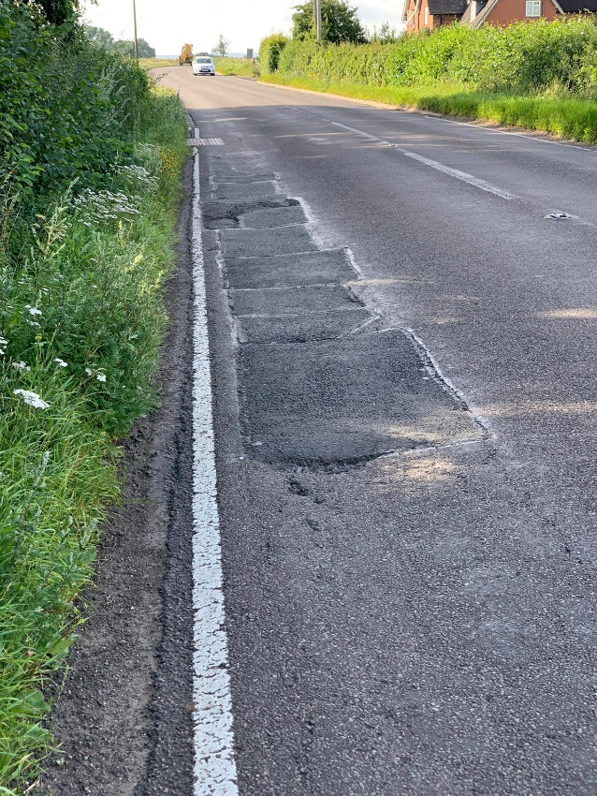
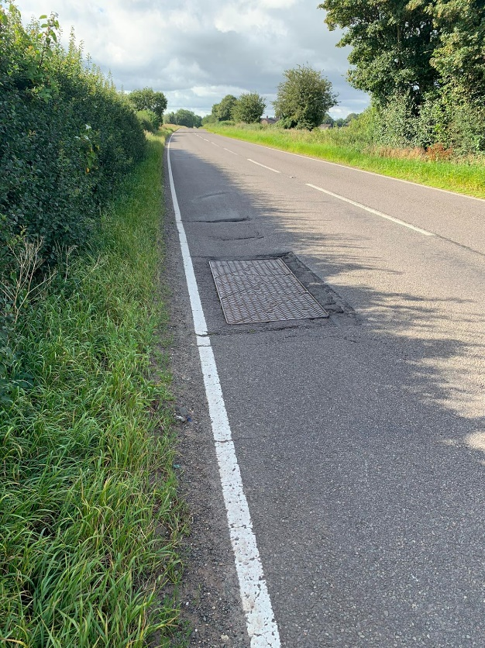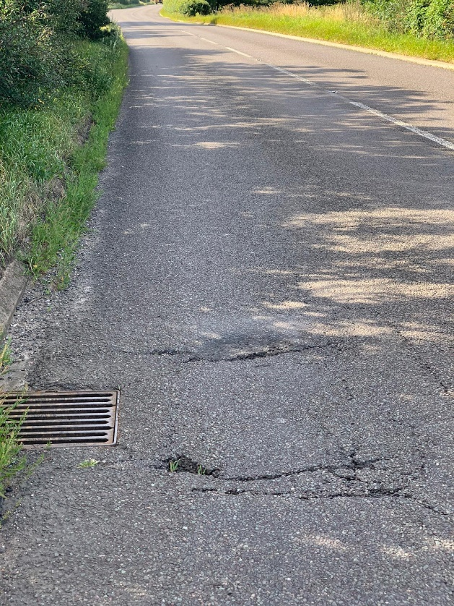

Reserves:- Due to Covid 19, the race field has been restricted to 60 riders. The race has been oversubscribed so there are a number of riders on the reserve list. If you cannot ride, please contact Steven Ford on 07930 425153 as soon as possible so we can endeavour to swop your place for one of the reserve riders.

Results:- Full results will be posted on the CTT website & on the SCCA website https://shropshirecca.uk/
Any complaints or result queries should be made to the Event Secretary within 48 hours of the race finishing.

SCCA CHAMPIONSHIP 10 Prizes:-
Medals for the first 3 SCCA riders overall, Vets on Standard, Women & Juniors. The medals will be presented at the annual SCCA prizegiving ceremony.

Nova Raider Open Prizes:-
1st Fastest Man £20 1st Fastest Veteran on Standard £20
2nd Fastest Man £15 2nd Fastest Veteran on Standard £15
3rd Fastest Man £10 3rd Fastest Veteran on Standard £10
1st Fastest Woman £20 Fastest Junior £10
2nd Fastest Woman £15 Fastest Team of 3 £10.00 each
3rd Fastest Woman £10
(One rider, 1 prize except for the team prize).
Please note, there will be no prize giving on race day. Prizes will be distributed afterwards ideally via bank transfer or cheque.
Course Records:-
Men:- Josh Williams 19:47 (March 2016)
Women:- Hetty Niblett 22.54 (Jun 2018)

Thanks:- We would like to thank all the marshals, helpers and officials who have made this event possible. We hope all riders have an enjoyable morning and have good, safe and fast rides.

Event Secretary, Steven Ford:- 07930 425153
On the day Event Organiser, Gary Wade:- 07948 383429

Additional Race Items Checklist for 2020:-
- Sign on pen,
- Hand sanitiser,
- Safety pins,
- Rear light.

